Calculations

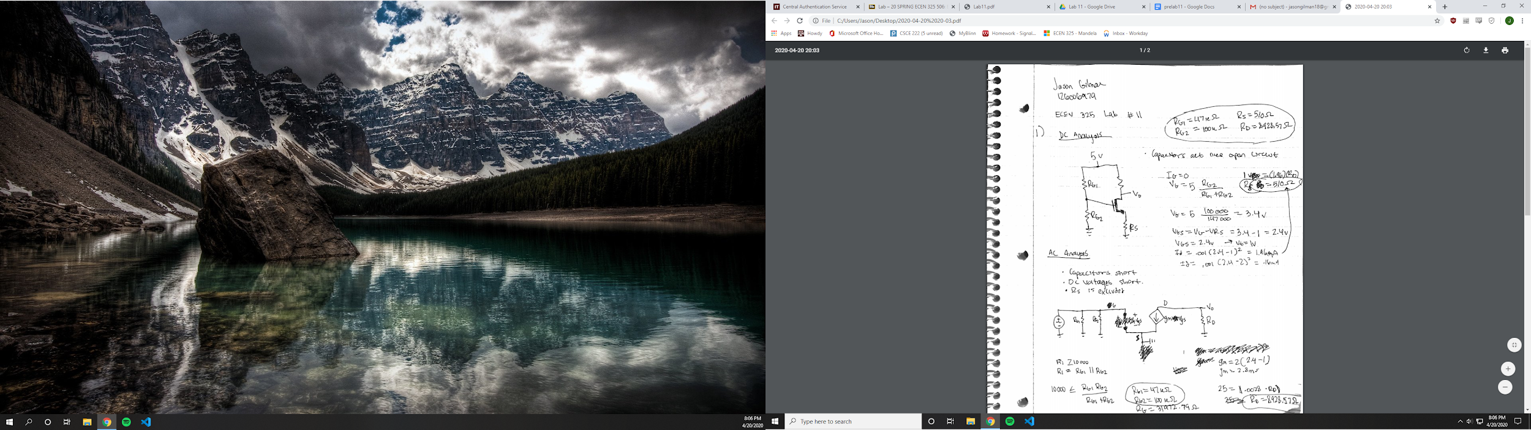

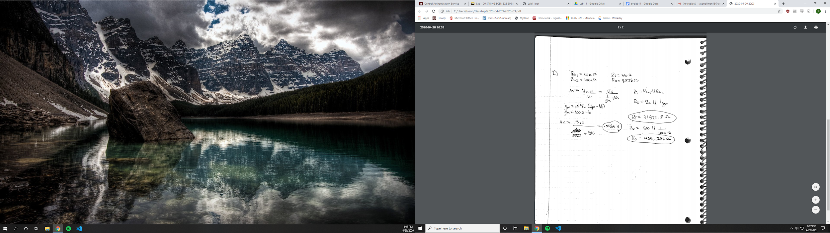

Simulations

Common source

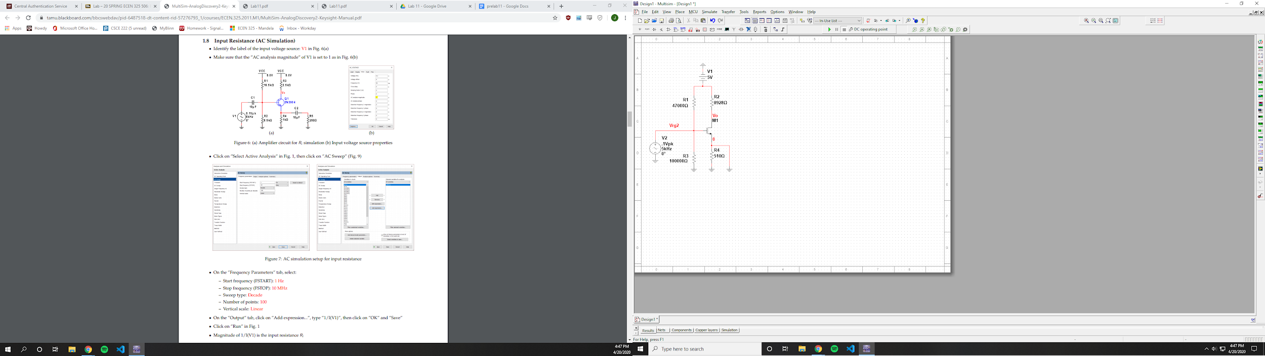

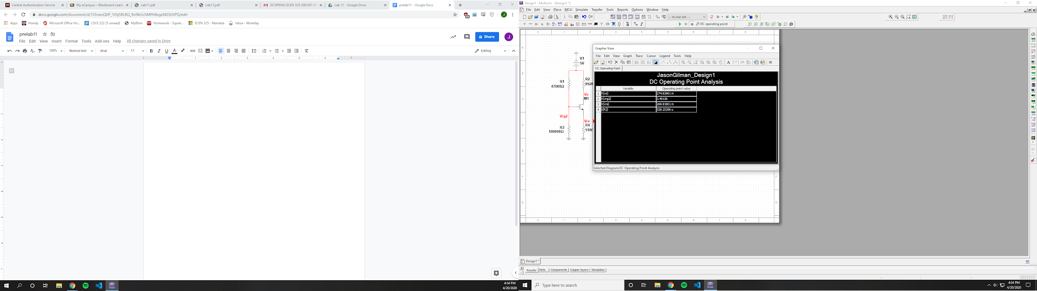

Vrg2 = 3.40136 V

Vrs = 269.91901 mV

Id = 529.25296 uA

Vd = 274.82961 mV

Vo = 274.82961 mV

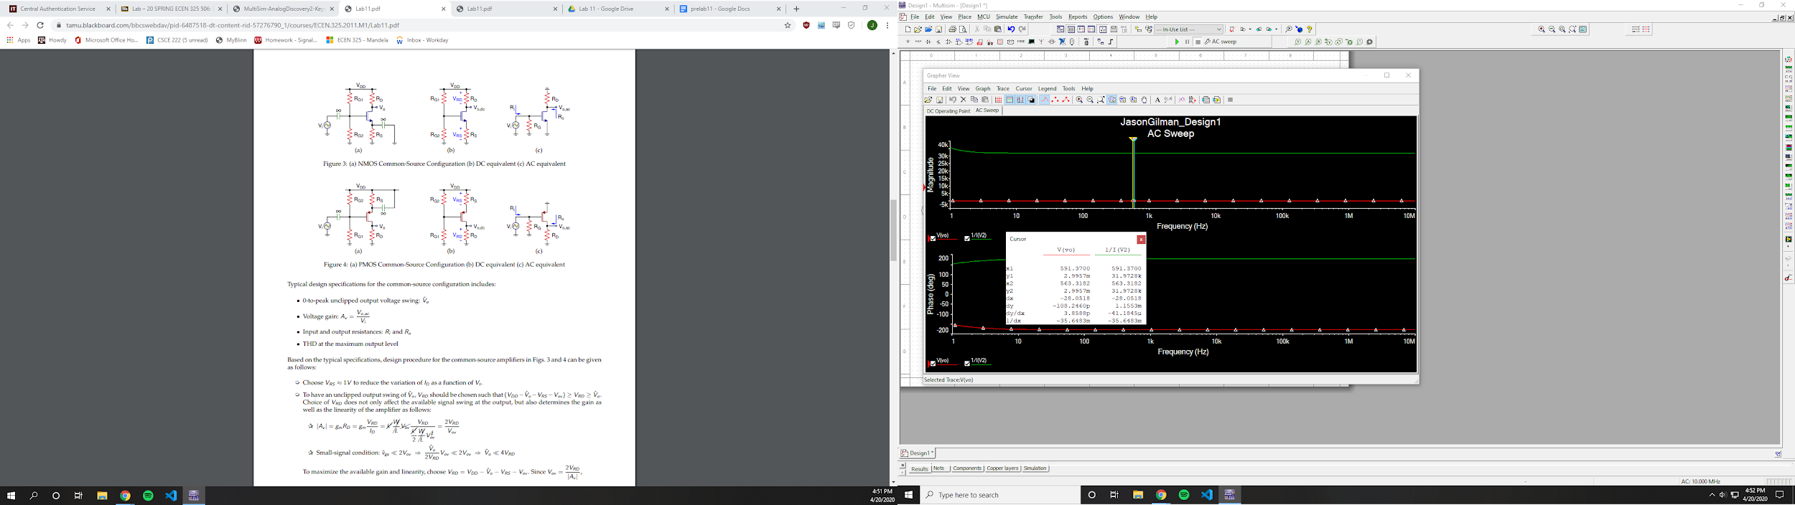

Ri = 31.9728 k Ohms

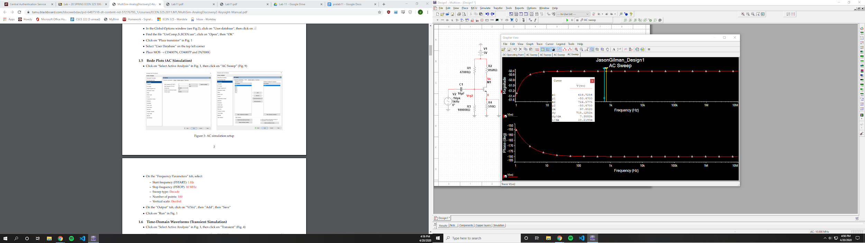

Av = -50.47 dB

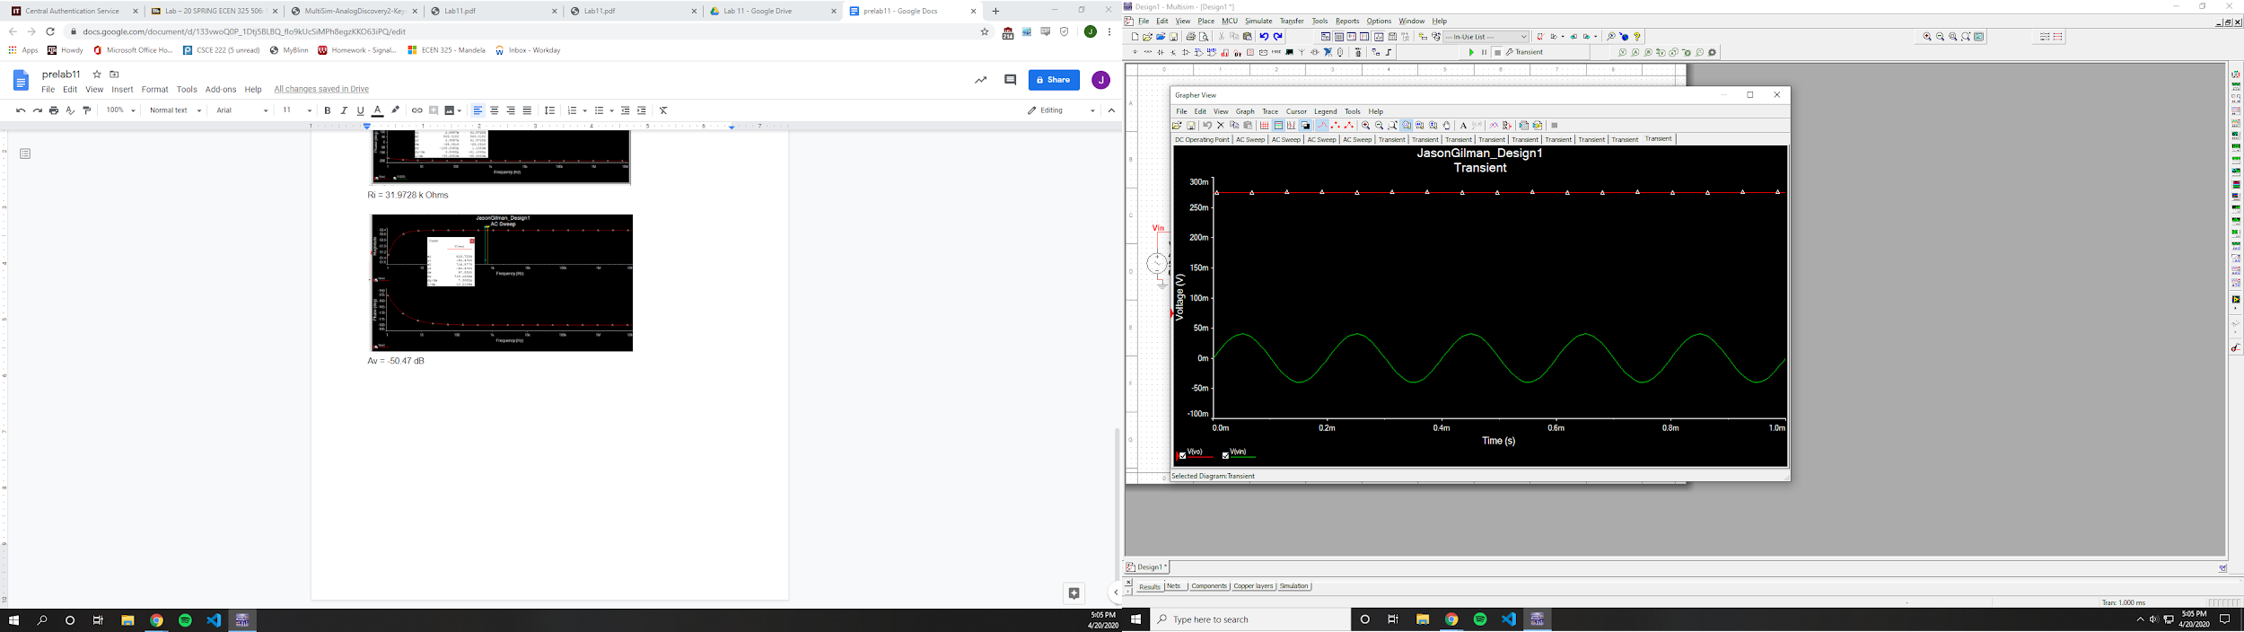

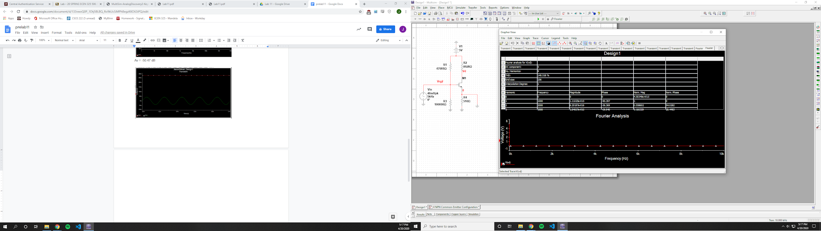

THD = 140.518%

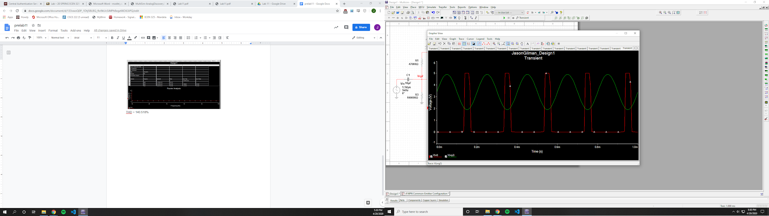

V_clipping = 1.5 V

Source Follower

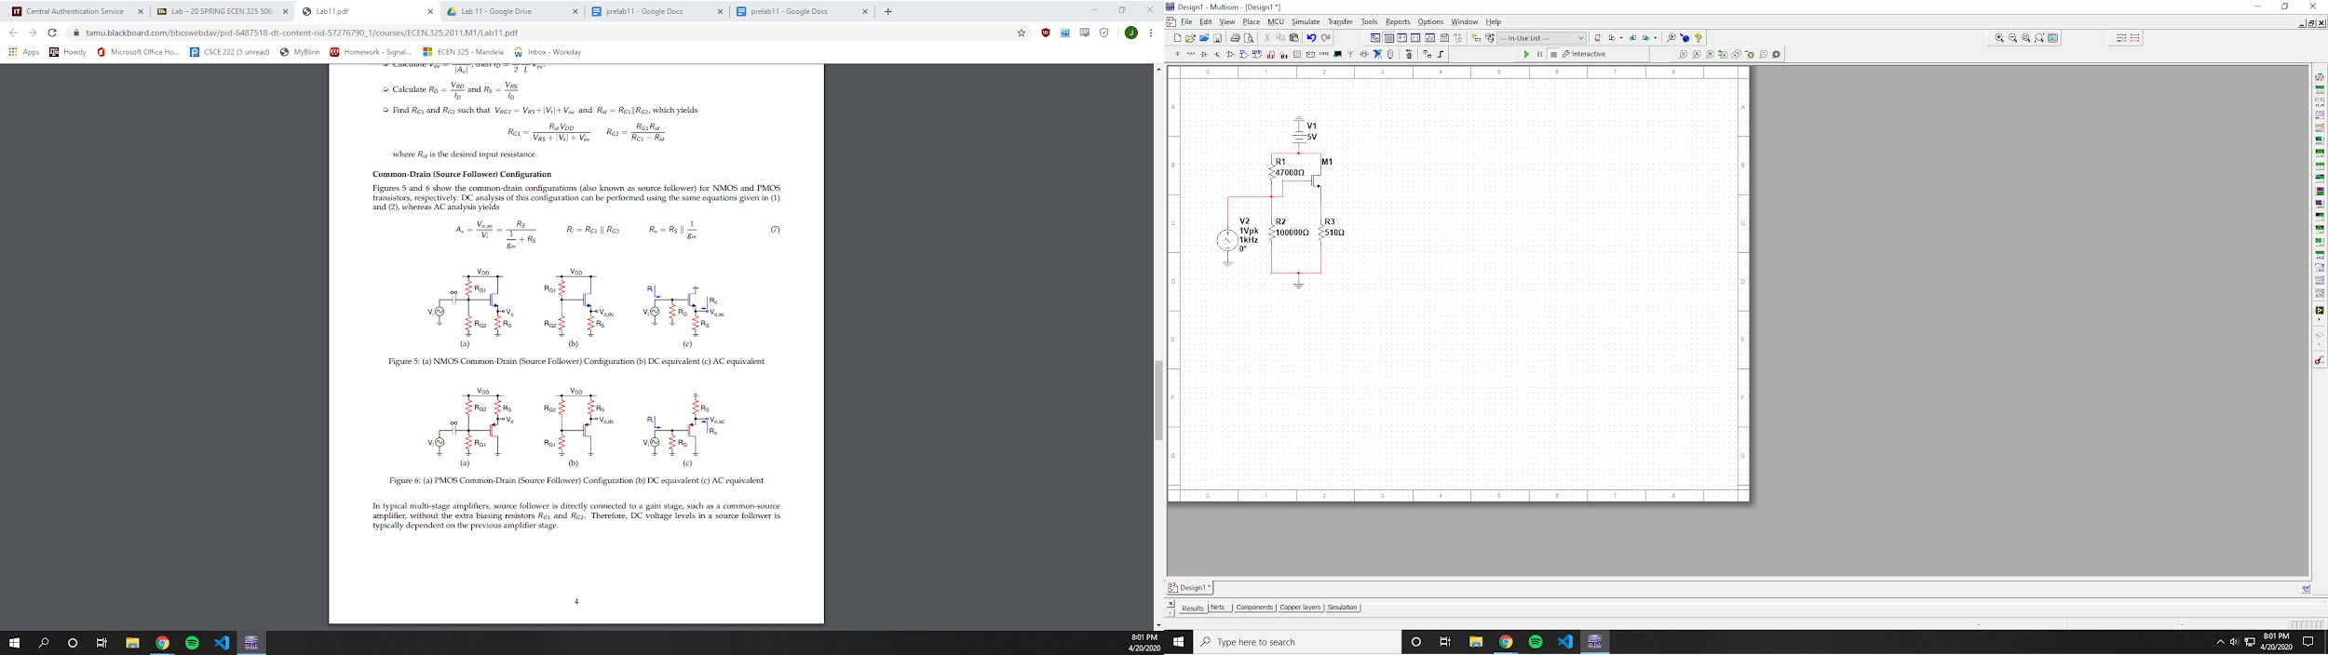

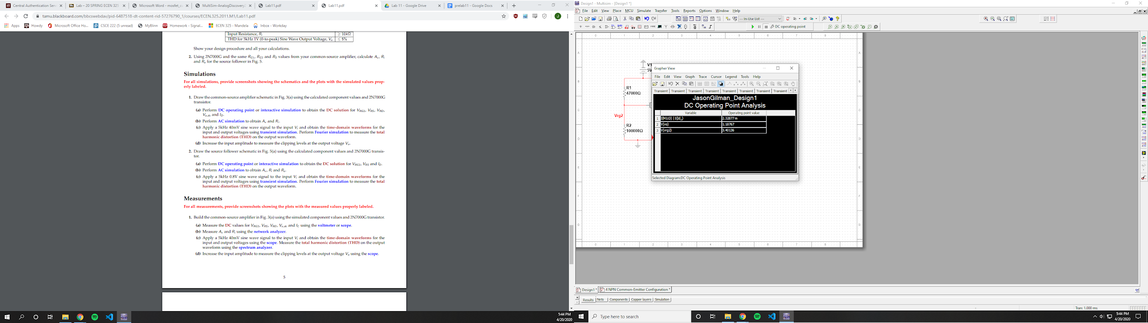

Id = 2.32877 mA

Vs = 1.18767 V

Vrg2 = 4.40136 V

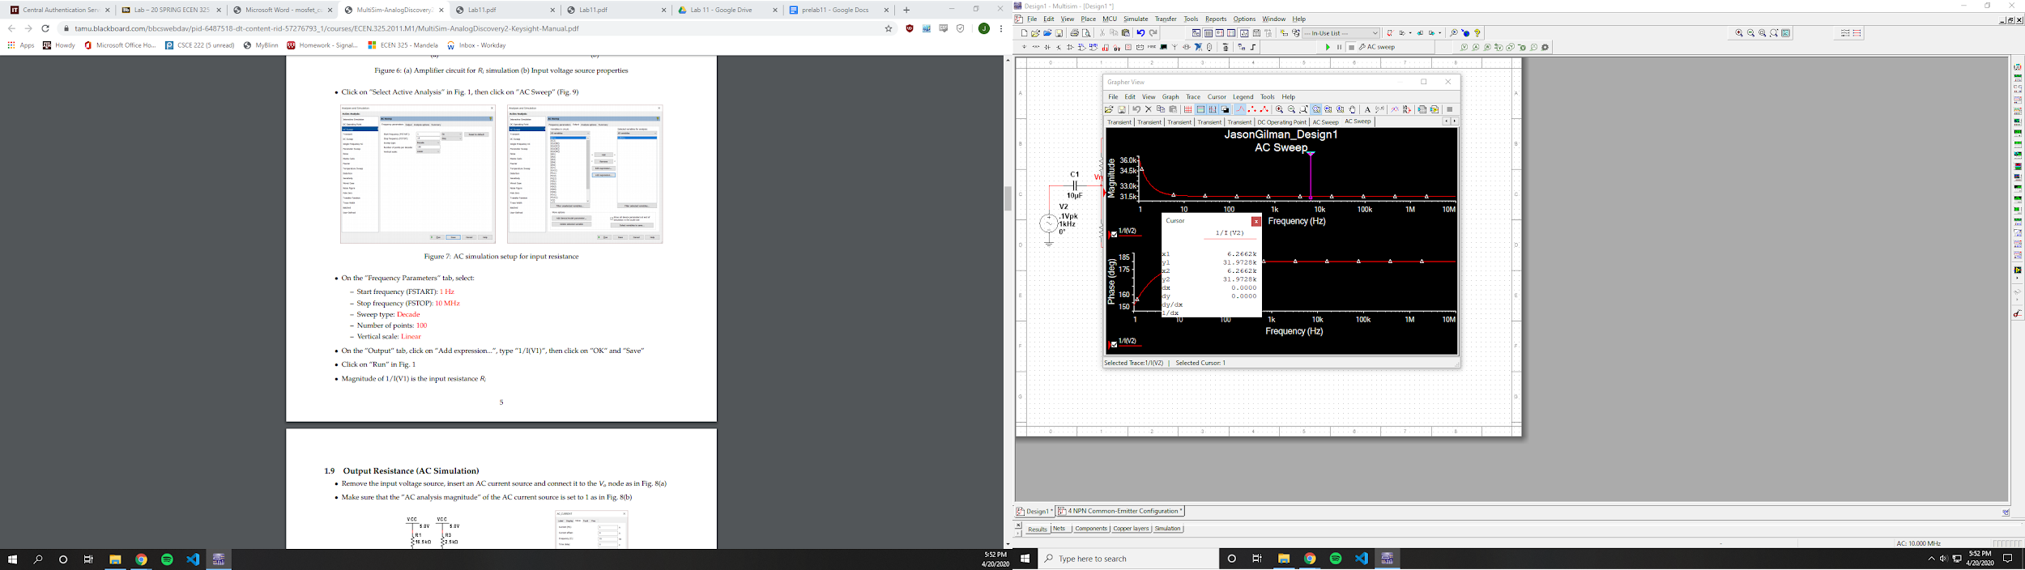

Ri = 31.9728 kOhms

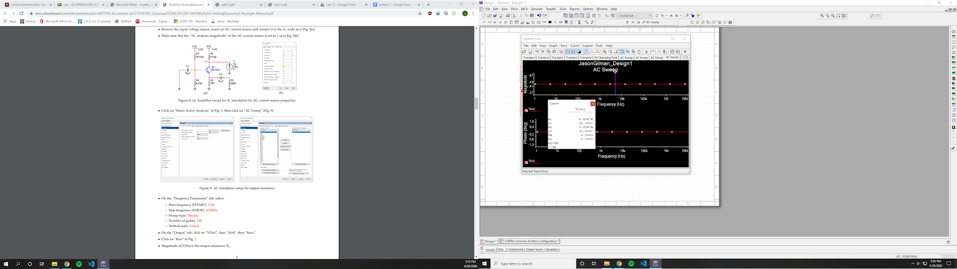

Ro = 42.0931 Ohms

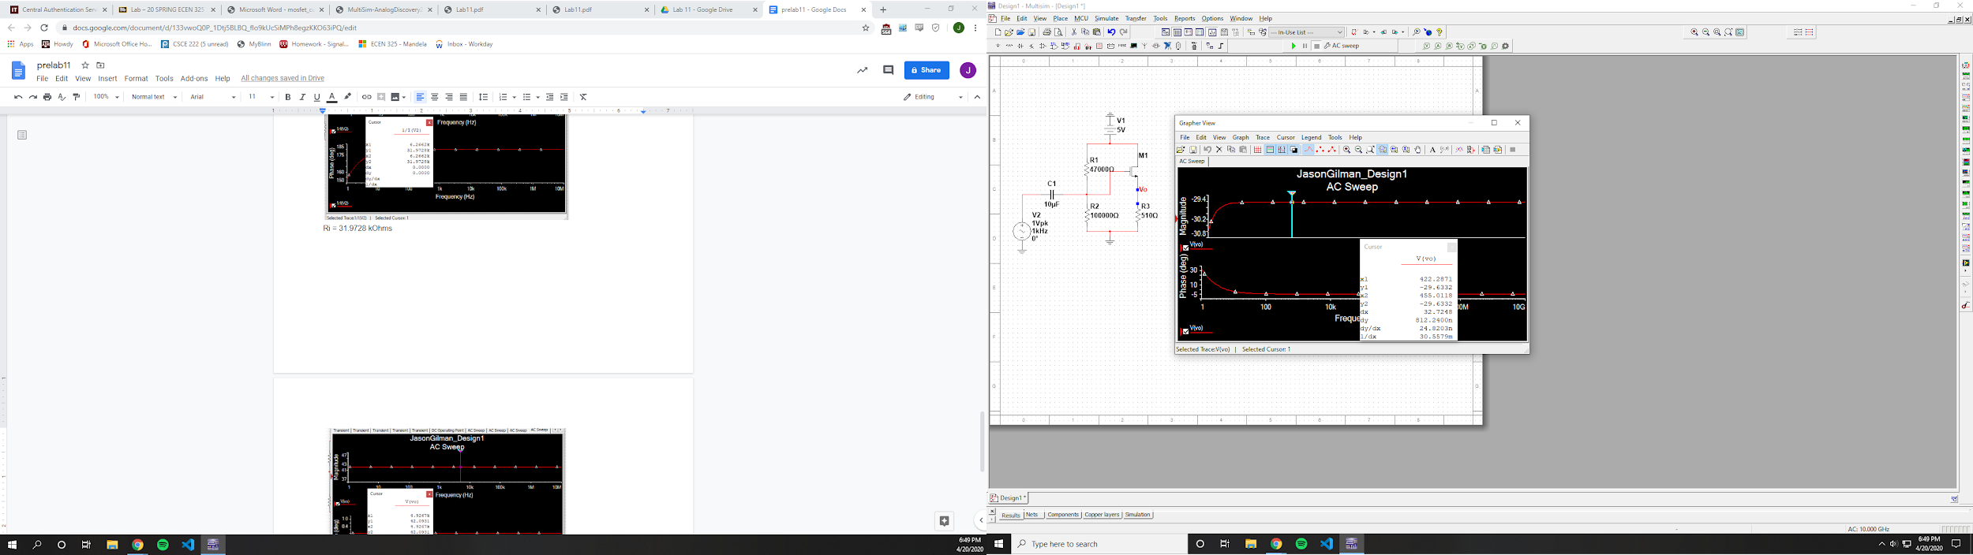

Av = -29.6332

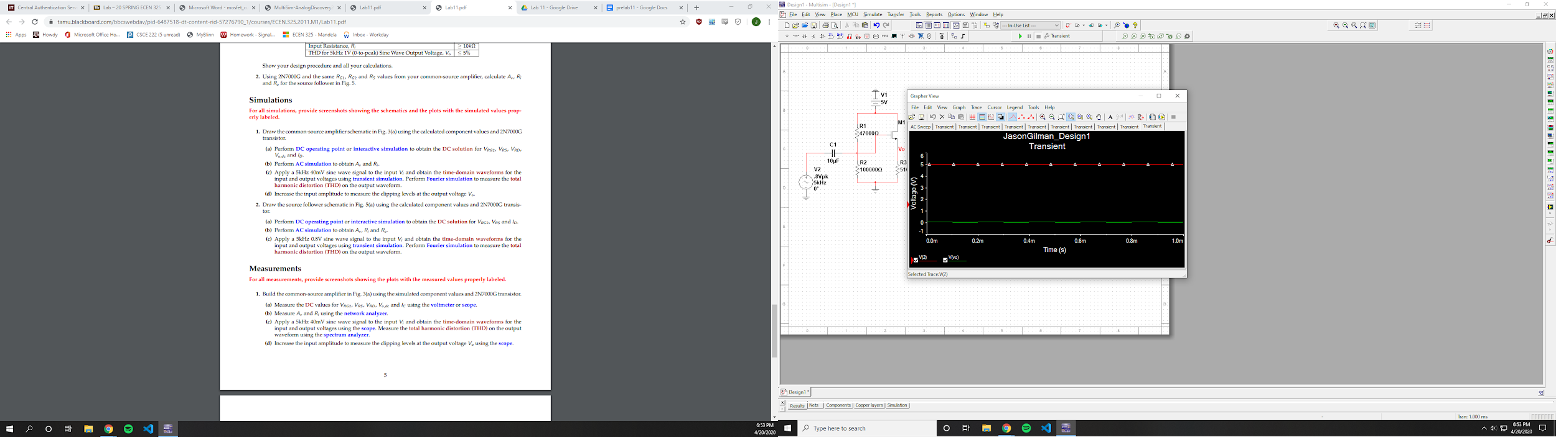

Had trouble getting the vo to show correctly

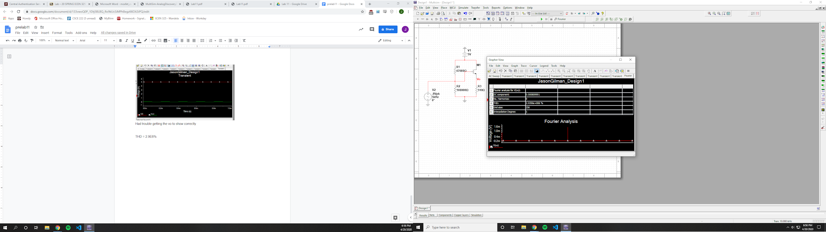

THD = 2.9E6%